Код таблиц:

CREATE TABLE groupp (

id INTEGER PRIMARY KEY,

name VARCHAR(255) NOT NULL,

description VARCHAR(255));

CREATE TABLE student (

id INTEGER PRIMARY KEY,

name VARCHAR(255),

group_id INTEGER REFERENCES groupp(id) NOT NULL);

CREATE TABLE student_grades (

student_id INTEGER PRIMARY KEY,

math_grade_avg FLOAT,

physics_grade_avg FLOAT,

python_grade_avg FLOAT);

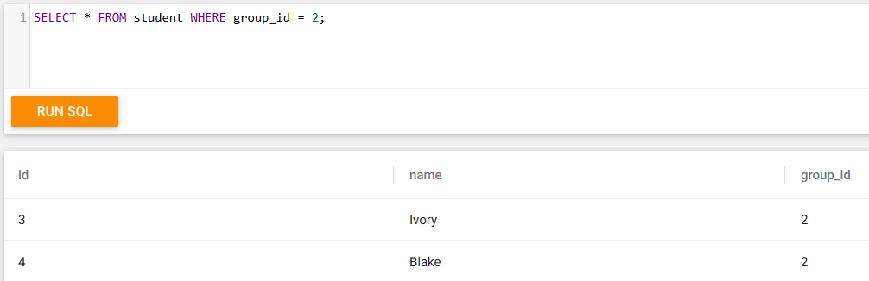Запросы:

